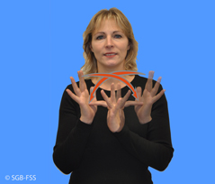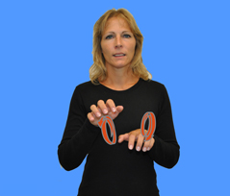 **Diese Tiere lebten in Jesu Dorf.**

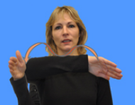

**Kamel**

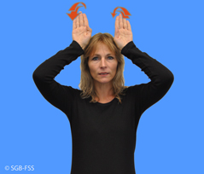

**Esel**

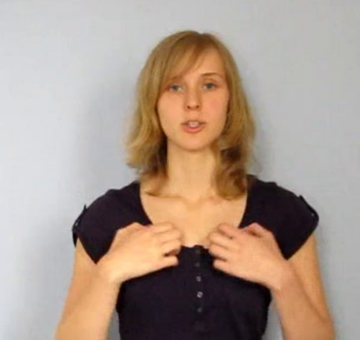

**Schaf**

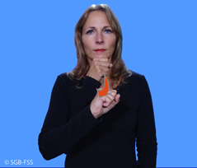

**Ziege**

|  |  |
| --- | --- |
| **C:\Program Files\Picto Selector\png\ARASAAC Symbol Set\2489.png** | **C:\Program Files\Picto Selector\png\Mulberry Symbol Set\donkey.wmf** |
| **C:\Program Files\Picto Selector\png\ARASAAC Symbol Set\25887.png** | C:\Program Files\Picto Selector\png\ARASAAC Symbol Set\8522.png |

|  |  |
| --- | --- |
| **C:\Program Files\Picto Selector\png\ARASAAC Symbol Set\2489.png** | **C:\Program Files\Picto Selector\png\Mulberry Symbol Set\donkey.wmf** |
| **C:\Program Files\Picto Selector\png\ARASAAC Symbol Set\25887.png** | C:\Program Files\Picto Selector\png\ARASAAC Symbol Set\8522.png |

**C:\Program Files\Picto Selector\png\Mulberry Symbol Set\donkey.wmf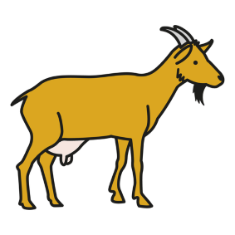Diese Tiere lebten in Jesu Dorf**

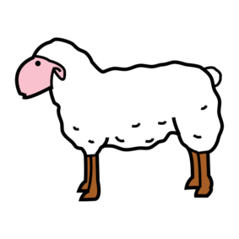

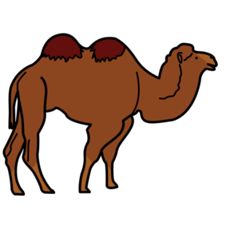_______________________________________________________________________________

C:\Program Files\Picto Selector\png\Mulberry Symbol Set\horse.wmf

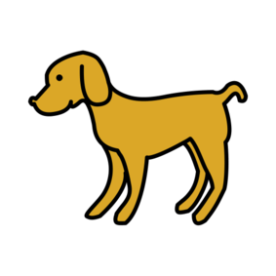

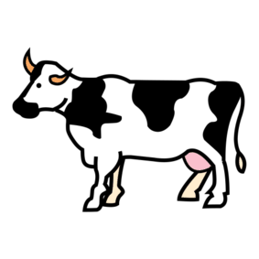_______________________________________________________________________________



C:\Program Files\Picto Selector\png\Mulberry Symbol Set\chicken live.wmf

_______________________________________________________________________________